



Rostering Requirement Document

Shift Rostering: A fair and cost-
Effective workforce plan for staff


Contents

1 | Rostering
2 | Getting Started
3 | Why use Real-time Rostering?
4 | Benefits
5 | Background
6 | proposed system
7 | iris scan and data collection
8 | integration with SAP
9 | Integration with SAP and role of each party
10 | Handling Errors
11 | Shifts creation
12 | Clinical Units
13 | Shift creation guidelines
14 | Clinical units requirements
15 | Shift roster creation
16 | System feature list
17 | System architecture
18 | hHardware and technology requirements


Safer, fairer rosters that
improve patient care

Getting your roster right is more than important; it’s critical. Making sure you’re being cost effective in the delivery of your service, as well as ensuring the wellbeing of your skilled workforce is imperative.

Timenex Rostering system enables organizations to plan ahead and deliver the service required. It enables organizations to ensure the correct combination of skilled people are working as needed, in the safest and most cost-effective way, while providing the opportunity to flex the workforce if demand changes.

The Document

The roster requirement documents or report on project “Time & Attendance System (Software & Hardware)”is the outcome of the preliminary study of Naufar. This document is the product of the many discussions with the Naufar team. This report concentrates on project activities being launched, therefore, producing the commencements highlights. Also this report concentrates mainly on implementation of the project covering study, customization, integration, deployment, trainings and support aspects of the project.
M/S TESS has initiated this project through planned activities like, initial planning, staff assignment, identification and definition of deliverables, risk planning, consideration of environmental constraints, training plan and support mechanism etc. with the following major outputs:
- To study the business process of Naufar relevant to attendance and preparation of detailed document for customization
- Customization of a highly interactive and dynamic automated solution which shall cover all processes relevant to attendance
- Integration with the existing SAP system HR module, using the previous collected data
- Provide training to personnel of Naufar for maintenance and operations
- The roll out of the application and support services
Regarding technological aspects of this project, the system architecture is like hub and spoke all modules. Therefore, Model-View-Controller (MVC) Architecture is the base architectural design and the PHP-MSSQL as backend would be development framework among a number of development frameworks selected for this project. The security of this automated system and its data is a paramount concern envisaged within its development phases.
Easy to use low cost solution

Our e-rostering software users reported a significant reduction in administrative time to create and distribute complex rotas, as well as a clear a reduction in the number of mistakes made due to the reduced margin for human error. There have also been reports of an important increase in the accuracy of their workforce deployment based on skill mix. The subsequent improvements in productivity are tangible having achieved the right person with the right skills just where and when they are needed.
Developed by workforce experts Skills for Health, our rostering tools are therefore built with a critical understanding that errors in the workforce plan can have an exponential impact on any service. Initially designed for the healthcare sector, our tools are robust in their functionality to deal with all complexities associated with rostering, so you can have confidence in our accuracy and learning over the last 10+ years.

Seamless system integration

We work with organizations to
ensure seamless integration
into existing systems such as;
HR, Payroll, Time & Attendance.

Roster all staff

Roster your whole workforce in one system. Real-time caters for the different working arrangements and contracts of consultants, junior doctors and Agenda for Change staff such as nurses and support workers.

Getting Started

Getting workforce rostering right
Getting your roster right is more than important; it’s critical.
Timenex Rostering helps organizations deliver a fair workforce plan for staff and service delivery. As part of the organization change involved in implementing a dedicated rostering solution, you might come across some issues. Below are a few tips you might find useful:

Involve senior staff

It is always good to involve senior staff in the implementation process from the start. This will allow senior staff to understand the system first hand and promote the system to other staff.

Forward planning
Choosing to roster electronically not only saves time, it is also more efficient as the system enables staff to clearly identify gaps in the rotas and plan ahead accordingly. All information is saved online and can be accessed at any point.

Take staff on a journey
Implementing e-rostering is asking for a major organizational change and is a big step for staff. Staff need to be taken on a journey so they can see the benefits of the e-rostering system. All staff need to see fairness of allocation and transparency – and the benefits to the individual – maintaining a work life balance.

Why use Rostering?
- Create and distribute long term rotas that can detail over a year in advance, specifically designed to meet the needs of your service and well beingof Naufar staff
- Keep track of the historical rota and flex into the future to ensure cost-effective use of available staff
- Avoiding using more expensive temporary staff at last minute incidences to fill an unseen need.
Its Benefits

- Supports deployment of right people in the right place at the right time;
- Realtime updates staff rotas in seconds, providing accurate and up to date information;
- System allows staff to access their details and rotas online 24/7;
- Enables compliance, saving money and most importantly meeting staff needs;
- Takes into account factors such as annual leave and shift swaps to help staff manage their time etter;
- Greater work / life balance and higher staff satisfaction.
Easy to use low cost solution:
- Cost effective online solution for creating rotasand delivering smooth day-to-day working;
- Enables rosters to be managed across multiple sites;
- Accessible online to all relevant staff at anytime and via Smartphone;
- Robust auditing and reporting functionality;
- Low cost solution that delivers significant savings and return;
- Better use of senior staff’s time – as they can spend less time on scheduling;
- Plan up to a year in advance, with flexibility to plan around unexpected absences and take account of annual leave and shift swaps.

Background

Naufar is a healthcare sanctuary under construction in Doha, Qatar with its primary focus to treat substance related and addictive behavioral disorders along with services for non-cancer patients with chronic pain and comorbid modifiable disease conditions using an integrative wellness approach incorporating medical, psychosocial and physical approaches. An extensive range of hospitality products will be offered including a spa, a gymnasium, restaurants, a conference centre and meetings rooms all to be supported by a highly personalized level of service.

Vision  To be recognized as a centre of excellence within 3 years from opening. |  | Mission  Assist people with behavioural disorders to achieve and sustain the quality of life they aspire for, in a healing environment using evidence based practices.

Key features of the sanctuary include:
- Person-centred therapy in a world-class hospitality setting
- Continuum of care underpinned by a therapeutic alliance, tailored to the individual guest’s needs and wishes
- Long-term support to aid the transition to a fulfilling and successful personal, family and work life and the achievement of aspirational goals
- Science-based treatment to take advantage of leading-edge developments now and in the future
- Integrated programs offering medical, psychotherapeutic, wellness and self-help interventions
- Multidisciplinary treatment teams and separate programs for men, women and adolescents
- Integrated leading-edge technological systems and solutions
- The highest professional standards will be the hallmark of Naufar services

Proposed System

The new proposed time and attendance system shall streamline Attendance and Leave management functions of Naufar. The purpose of this iris bases attendance system is introducing a transparent attendance system for staff across the organization.
The Naufar aims to maintain a proper record of attendance of Employees for effective functioning and management. Designing a better attendance management system for employees so that records are maintained with ease and accuracy is an important key behind motivating this project. This would improve accuracy of attendance records. Current employee’s absenteeism rates seriously disrupt the consistency of the organization’s working environment. First, employee absenteeism and late coming seriously affects the organization itself and secondly to disturb the work environment. Also, there are substantial financial costs associated with employee attendance. To overcome this issue, Naufar intends to introduce an integrated attendance system across organization. The system would be based on a centralized software application supported with SAP and can be monitored through different desktops/mobile across the organization.
The preliminary study, the requirement and production of this document being pre-requisite of the implementation process are thereby taken on. This document is outcome of consultative process of all stakeholders, where the team arranged stakeholders meeting to discuss the core implementation ambition and critical issues. This document concentrates mainly on implementation and execution process blueprints, project scope and client-customer synchronization on the task.
The document mainly focused on the following:
- The study of the client prospect
- Manage all employee Attendance (Clinical and Non-Clinical)
- Workforce Planning (Shift Management )
- Employee Attendance Management
- Migrate historical data to the new system
- Develop and Implement reports as per business requirements
- Functionality customization and development of shift roster module
- Real time Integration of Time and Attendance system with Naufar SAP for HR Module
- Shift roster (optional)
The output of this implementation would ensure the following:
Switch attendance from simple system to smart iris based attendance system
It will increase punctuality ratio, accuracy and ease in attendance management. Here, Naufar will get not only electronic attendance system but also an online attendance system.
Tracking attendance, managing holidays, overtime, duty roster, etc
    - In general, the system shall provide the report of the employee worked hours and helps in payroll management. One can track the absenteeism and late comers as well.
    - Time attendance system is not only for simply recording the employee time in/out and calculating the hours worked by employees in a week or a month. It is more about making the employees responsible in their job by bringing punctuality and consistency in time management. This attendance system is designed in such a way that all employees can view their attendance records. They can view how punctual they are to their job, how many hours they are working every day etc. This kind of interaction with the system helps a lot for employee time management.
Apply Leave, Approve leave, Manage Leave
The attendance system along with the leave management system would give detailed information about the employees on attendance, leave and official visit. This will help to manage to plan/approve the employee leave as well.
Iris based Attendance System
Is an innovative attendance system based on web based software application with LAN based connectivity with Iris scan devices for the time attendance applications. It will be equipped with the fastest commercial-based iris matching algorithm and high-performance, high-image quality optical iris sensor. The screen can display more information vividly, including iris image quality, time/date and verification result etc. LAN communication is standard and makes sure the data transmission between terminal and Server could be easily done within few seconds. This system is on Three Tier Model which includes attendance Machines, Application Server and Database Server. Virtual Private Network makes it easy to secure all the transmission on the internet.
With high speed processer at device level and optimized iris recognition algorithm, system should offer the best recognition rate. This Web based attendance system stores Iris data and employee details. User time-in, time-out and attendance logs are stored in the server. Administrators could interact with data being sent using this device through the central server. All departments would be connected through LAN connectivity with the server. Authorities would be able to access this system through their android smart phone and computer systems. Only authenticated users would be able to connect with the Attendance System’s reporting application.
Thus the system offers enterprise level of Entry and Time Attendance management with its LAN based communication infrastructure enabling integrated monitoring and systematic management through multiple terminals operated independently on remote locations. The system will have functionally the following properties:-
- The system registers an employee and stores its iris through a iris scan algorithm.
- It then identifies an employee by matching the iris of an employee to the one it has stored through the iris registration process.
- The system is based on the iris scan, record the date and time of the iris scan of the employee and store the ID, date, time and other relevant information in a database system.
- The system does this for both in-time and out-time.
- The system generates and sends attendance summaries, alerts, leave request, leave approval status through email to all stakeholders and management
- The system is able to display and print the attendance information to the authorized staff at the local site. More over the attendance data recorded through the fingerprint biometric system should be sent / synchronized with a remote/central database server; where all the attendance data will be consolidated.
The system has a local as well as a remote attendance management interface, a reasonable security mechanism and good quality performance
Managing Naufar units
There are a number of units currently active inside Naufar. The system shall be configured in such a way that it shall manage large number of units. The management facility shall be allowed to administrators at Naufar; they after login to system can add or edit information of any unit inside the Naufar vicinity.

Shifts Management
Newly proposed system shall integrate all current shift management and its work processes. The Naufar shift management shall receive best features of the system incorporating all shifts types. The system shall be configured with SAP to fetch the shifts definitions and feed into its own database. The shifts defined by the main system shall be further implemented by the time attendance system.

The data collected based on these running shifts shall be transferred back to main SAP system where reports generated based on time in time out shall be used in payroll management.

The system shall allow the managers to create shifts based on the requirements of each unit. The manager after creating the shift can view and can easily manage duties assigned to staff members. The system shall allow manager to manage swapping two employees, mark leave, mark on call etc.

The newly proposed system shall allow managers to create the easily with its easily understandable interfaces, and shall provide and easy interface to make changes to duties or shifts. The system shall provide all the features with an organized view structure.

The shifts managers can view a large number of reports and can built customized reports. The managers are allowed to view and print every report.

Skills Management
Duties are assigned to staff members based on their skills set. The system shall allow the administrators to add or edit any of the employee skill. These skills after adding with employee shall appear to shift managers while creating any shift. Based on skills the shift managers decide to place employees in units.

Designation Management
Every staff member has its own designation, for each unit the shift managers require certain number of staff having different type of designation. The employees are hired against a specific designation and also they are assigned duties in units as per job descriptions. The newly proposed system shall be allowed add or edit the designations maintained in Naufar.

Integrated with SAP
For the master data like employee’s information shall be transferred from the main SAP system to the time attendance system. The main SAP system shall provide data through SOAP requests and the time attendance system shall integrate all the data provided by the SAP system.

The SAP system shall provide the web service to time attendance system and as per request of the system or by manual click the data shall be requested, fetched and dumped into time attendance system.

Iris Scan and Data collection

Iris recognition verification is one of the most reliable personal identification methods in Biometrics. With the rapid development of iris recognition verification, a number of its applications have been proposed until now including time attendance system etc.



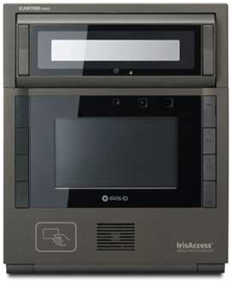



This system based on Iris scanner and wireless technique solves the problem of spurious attendance and the trouble of laying the corresponding network. It can make the users’ attendances more easily and effectively.

Scan
Match Scan
Store Data
Database
Attendance Data

Compared to fingerprint, iris is protected from the external environment behind the cornea and the eyelid. No subject to deleterious effects of aging, the small-scale radial features of the iris remain stable and fixed from about one year of age throughout life. A number of groups have explored iris recognition algorithms and some systems have already been implemented. A typical iris recognition system generally consists of the following basic modules:
- Image acquisition, iris location, and pre-processing,
- Iris texture feature extraction and signature encoding, and
- Iris signature matching for recognition or verification.

The great advantage of the authentication using iris recognition is the irreplaceable nature. Through the analysis of the overall and local characteristics of iris recognition such as eyelid, sclera, pupil, we can extract enough detail data. Such data is unique to the individual and remains so throughout one’s life. We can use these data to identify or verify a person operating as follows:

- A digital image of one person’s eyes to be verified is captured;
- A feature extracting algorithm is carried out;
- Minutiae are extracted and stored as a template for verifying later;
- People to be verified place his eye on the iris recognition sensor so as to extracting the minutiae from the captured image;
- A matching algorithm is applied to matches the minutiae with the stored template previously.

Iris Benefits

- Iris recognition technology offer Dual or Single eye capture and automatic identification again large databases in just 1-2 seconds.
- Iris recognition is considered more secure compared to fingerprint and other biometric technologies.
- Many people have improper fingerprints that are not suitable for fingerprint recognition systems. Iris is second best alternative to fingerprint.
- Children fingerprints are difficult to scan and can go thru changes overtime, making it not a suitable biometric identification. Iris is suitable for all ages.
- Eyes are highly protected part of the body and does not go thru much changes over the complete lifespan and good for long terms biometric recognition
- Iris recognition technology is worldwide used in National ID, Visa entry exit applications

Time Attendance System

Attendance Management System is the easiest way to keep track of attendance for large organizations. Attendance Management System covers the requirements of the Personnel Department in terms of Man-power Analysis, day-to-day monitoring of the Attendance, Maintaining Statutory Registers, Monitoring of Leave Records, Calculation of Overtime and transfer of relevant information to the Payroll System.










The time attendance system built for Naufar shall incorporate all the requirements into a key collection system where device shall sends data to server database. The Naufar currently implements the SAP where all the employees’ records are managed. The newly developed system shall be integrated with the SAP through the web services.

Match Scan
Search Employee
Mark Attendance
Store Data
Report

The web services shall be two-way where the SAP system shall have inbound and outbound services for data collection and supply to time attendance system. The devices shall collect data installed at various locations at Naufar, the collected data shall be directed to main server for storage into database.

These attendance devices can be configured to main server via internet or using the gsm connection. By any mean the data collected shall be transferred to main attendance system. Time attendance system shall after collection of data provides a variety of reports to its users having multiple types of reports from time in/out, absence report, weekly report, shift report etc.

The time attendance system is a web based system where it can be accessed via any modern era browsers. The responsive design shall facilitate its users to view or access the system via any device like mobile, laptop etc the system’s responsive behavior shall accommodate itself into any screen resolution.

Current System
The Naufar has already implemented the SAP S/4 HANA 1610. SAP has the best features for Human Resource Management. All the employees’ data is managed and processed through the SAP HR module. The mangers manage employee’s leave record and process payroll using SAP system and required management reports are produced through this system.

The Naufar aims to integrate HR data with the newly proposed system so that Time and Attendance system shall have all updated data collected via SAP HR modules. The migration shall be bi-directional. Any change in the SAP-HR module shall be mirrored at the Time and Attendance system also.

The current system doesn’t have any feature for shift roster. The shift roster shall be introduced in the newly proposed Time and Attendance system. The newly proposed system shall be able to manage the variety of shifts and shift roster. For shifts and employees the overtime calculation shall also be maintained by newly proposed system. The current system’s overtime calculation module shall be integrated to Time and Attendance system, so along with other module the overtime calculation shall be available to manager for reporting purposes.

The leaves record flow to DB server via the system, the newly proposed system shall be integrated in a way which shall mine all the leave record and embed to Time Attendance system. The SAP will be connected to the newly proposed system via gateways or APIs.

The first Step Integration with SAP

The newly proposed shall be integrated with the main SAP system. The SAP shall collect the master data and will provide SOAP based xml services to client or time attendance system to extract the master data.

The proposed system shall synchronize itself with the main SAP system extracting master data; the extracting shall in request format where the main SAP system shall first check for client’s request format/credentials and then provide the required data. The client or time attendance system after requesting data, shall get in XML format, the system shall have facility to read and store the same into its own database for future use.

Similarly the time attendance system shall play its own part to transfer the collected data to main SAP system. On request generated from main SAP the time attendance system shall generate an XML based response and from that response the SAP system shall extract the relevant data and saves to database. One each side the data shall be validated for integrity check if any ambiguity found within data the system shall report to managers and the issue shall be resolved. Below is the process that how both the system shall contact using defined structures:



Scope
Integration scope is Bi-directional data flow from SAP to Third party time recording Systems (TIMENEX) through SAP PI/PO system.

KAAR and Third Party Time Recording Terminals (TIMENEX) will work together to integrate SAP, Third Party Time Recording Terminals (TIMENEX) being used by Naufar. We are going to communicate with Time recording terminal using webservices through Process Orchestration (PO 7.5) as a middleware in other words SAP PI/PO (SAP middleware) will be used to send the data to webservice provided by Third Party Time Recording Terminals (TIMENEX).Also SAP Will receive the data through web services from Time recording terminals in the specified format which will be converted as a text file and uploaded using standard programs.

Outbound Interface:
- The time recording terminals will provide the web services to SAP upon which custom ABAP program will download the data and push to time recording Terminals through Interface program using PI.
- After pushing the data to Time recording terminals the data will be saved in the archived folder in the Excel or Text Format. The archiving will be maintained for last 15 days of data to address any discrepancies in the data with TIMENEX system.
- The first run will contain the full employee’s master data. Subsequent runs will be only for incremental data – (change, including additional new hiring.)
- There may be a need to run the program for full load later on. Hence, we will provide a checkbox for Full Load. If the checkbox for Full Load is checked, the download program will extract full data for active employees on that day. Otherwise, it will just extract incremental data
A background job program will be scheduled to run the download program once every night to extract the HR mini-master data from SAP. The data from SAP will be picked up by outbound interface program (SAP PI) and sent to time recording systems.
The detailed mapping is mentioned in the below document.

Inbound Interface:
- The time recording terminals will transmit the data through a webservice, which will be converted by SAP PO/PI as a text file and feed to the standard program as in put to upload the data in to SAP.
- SAP provides a standard upload program RPTEUP10 to upload time events into the interface table “CC1TEV”, which may required to be enhanced based on the data required in SAP.
- A background job will be scheduled and triggered once the data is transferred through the webservices by time recording terminals and gets upload to an interface table CC1TEV.
- HR Time Events Posting Program: After the file contents are uploaded into interface table CC1TEV, the next step is to post the time events from the interface table CC1TEV into TEVEN table. SAP provides a standard program SAPCDT45 to post time events from interface table CC1TEV into TEVEN table, which is required to modify to take only one in and one out in a particular day.
- A background job program will be scheduled to run this custom posting program once in a day to get the previous day records from CC1TEV interface table to TEVEN table

Objective of Integration
Objective is to record the clock in and clock out of each employee for each data from third party time recording terminals(TIMENEX)
Roster updating Periodically

Data Objects of Integration
Personal Information - Outbound from SAP
Roster definition - Master Data - Outbound from SAP
Absence record – Outbound from SAP
Public Holidays – Outbound from SAP
Clock in/Clock out – Inbound to SAP from Time Attendance system
Actual Roster - Inbound to SAP from Time Attendance System

SAP and Timenex Field Mapping

Personal Information: Outbound
Position | Field Name | Data Type | Table | Length | Short Description | Remarks for SAP Team
1 | PERNR | NUMC | Pa0001 | 8 | Personnel/Employee Number
2 | NAME | CHAR | pa0002 | 40 | Name of the Employee
3 | ORGEH | NUMC | Pa0001 | 8 | Organizational Unit
4 | PLANS | NUMC | T528T-PLSTX | 8 | Position
5 | DRS | NUMC |  | 8 | Supervisor’s Personnel Number | Same logic as Leave
6 | WERKS | CHAR | Pa0001 | 4 | Personal Area code
7 | NAME1 | CHAR | T500P-NAME1 | 30 | Personal Area text(Clinical or Non- Clinical)
8 | STAT2 | CHAR | pa0000 | 10 | Employment Status (Active or Separated)
9 | USRID_LONG | CHAR | pa0105 | 241 | Email Address

The SAP system shall provide the above mentioned table’s fields to time attendance system for fetching data to its own database. The SAP system shall prepare the response according to the above fields mentioned and make available to time attendance system via SOAP

Login to system

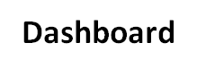

The system administrator shall login to the time attendance system by providing the user name and password. The authenticating the system shall him/her to access modules of integration.

User Name
***********
Login
Login page
u

user
Modules
View Reports

Employee Profile
The time attendance system after acquiring data from main SAP system shall sends to its data store and managers can access the same via time attendance employee’s module. The users can view already added employees list. The listed employee’s information can be edited via the editing forms. New fields are available to users to add more data.


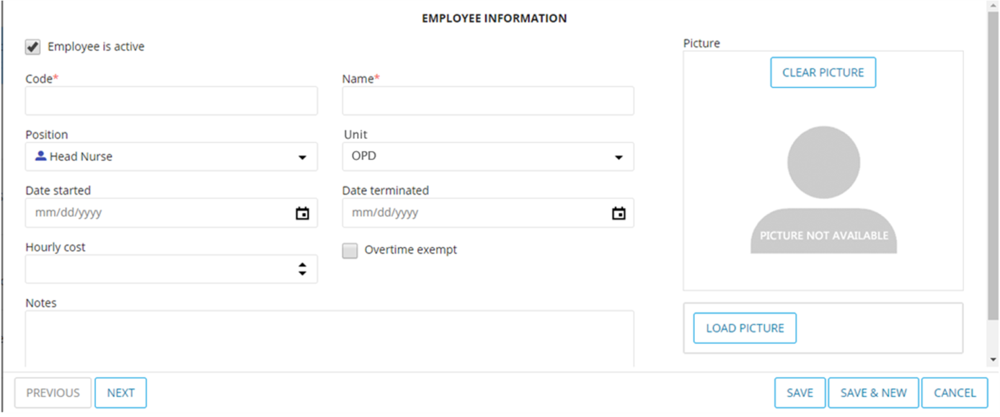

Emp Code
Emp Name
Search
Employee Module

user

Employee List
Already fetched records are listed [as shown below] in a view by the time attendance system, from below view the user can filter employees working at various units.

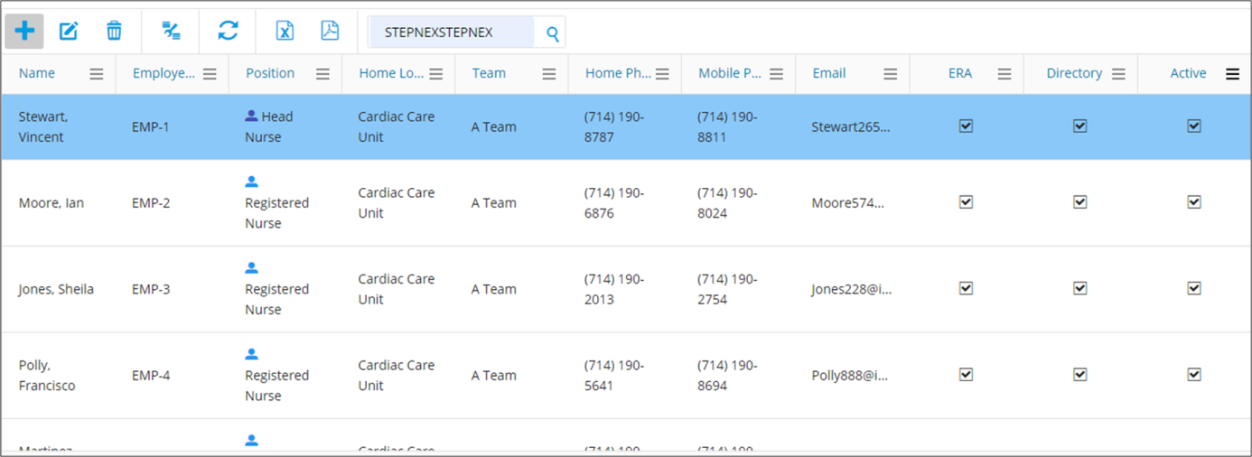

Emp Code
Emp Name
Search
Employee Module

user

Roster Outbound:
Position | Field Name | Data Type | Table | Length | Short Description | Remarks for SAP Team
1 | Roster_Code | CHAR | ZNAUF_PARAMETRS | 8 | Roster Code (e.g. SH-A) | Refer logic 1 below
2 | Roster_Name | CHAR | ZNAUF_PARAMETRS | 100 | Roster Name (e.g. Shift A) | Refer logic 2 below
2 | SOBEG | TIMS | V_T550A | 8 | Shift Start Time (e.g. 06:00) | Refer logic 3 below
3 | NOEND | TIMS | V_T550A | 8 | Shift End Time (e.g. 14:00) | Refer logic 3 below

Logic 1: Pass the Code name “NFRROS” in the parameters table mentioned in above table and take the value
Logic 2: Pass the Code name “NFRROS” in the parameters table mentioned in above table and take the value and description
Logic 3: Pass the Code name “NFRROS” in the parameters table mentioned in above table and take the process name against each value and pass in V_t550A and take start and end time

Shift Management
The main SAP system shall provide roster data on request to time attendance system. The T&A shall store the same to its database base. And will use the same as and when required during attendance operations. The below screen shows the already defined shifts; 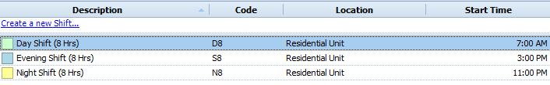

Absence: Outbound

Position | Field Name | Data Type | Table | Length | Short Description | Remarks for SAP Team
1 | PERNR | NUMC | PA0000 | 8 | Personnel number | Refer Logic 1
2 | AWART | CHAR | PA2001 | 4 | Leave Type
3 | BEGDA | DATS | PA2001 | 8 | Leave Start Date
4 | ENDDA | DATS | PA2001 | 8 | Leave End Date

Logic 1: Pass the employee number in PA0000 and check for the employment status i.e; STAT2=3.

Employees leave record shall be shared with the time attendance system, the shifts managers will be able to view reports on leaves, and also while creating shifts can look-into someone’s taken leave information. If the person is available for duties the system shall show them to allocate him/her any unit or shift. If an employee is on leave the system shall show a leave mark on employee record.
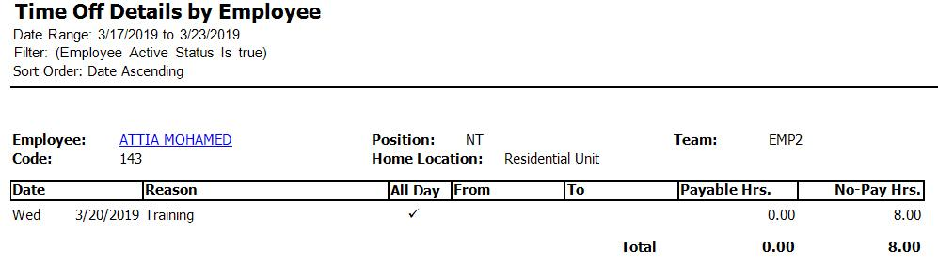
Public Holidays: Outbound
Position | Field Name | Data Type | Table | Length | Short Description | Remarks
1 | Holiday | CHAR | THOC | 30 | Holiday Name
2 | DATE | DATS | THOC | 8 | Date
3 | Holiday Calendar | CHAR | THOC | 2 | Holiday Calendar ID

Clock in/Clock out Inbound

Position | Field Name | Data Type | Length | Short Description | Remarks for Vendor
1 | SATZA | CHAR | 3 | Time Event Type | "P10” – for Punch In or “P20” for Punch Out
2 | LDATE | DATS | 8 | Login/Logout Date(YYYYMMDD) | “YYYYMMDD” Format
3 | LTIME | CHAR | 6 | Login/Logout Time(HHMMSS) | “HHMMSS” Format
4 | PERNR | NUMC | 8 | Personal Number
5 | DALLF | CHAR | 1 | “X” for Previous Day blank for current date | if the roster is continued to next day, TIMENEX Needs to provide the Punch Out date for the previous day instead of actual date of Punch Out, with indictor of X

Data collected at the iris devices shall be transferred to the main time attendance system. The collected data after being prepared for reporting and finalized shall be available to main SAP system. The SAP system shall sends request to time attendance system for specific data. The time attendance system shall prepare the data and will generate an xml based response for SAP. The SAP system shall extract data from response and will verify to check the integrity.

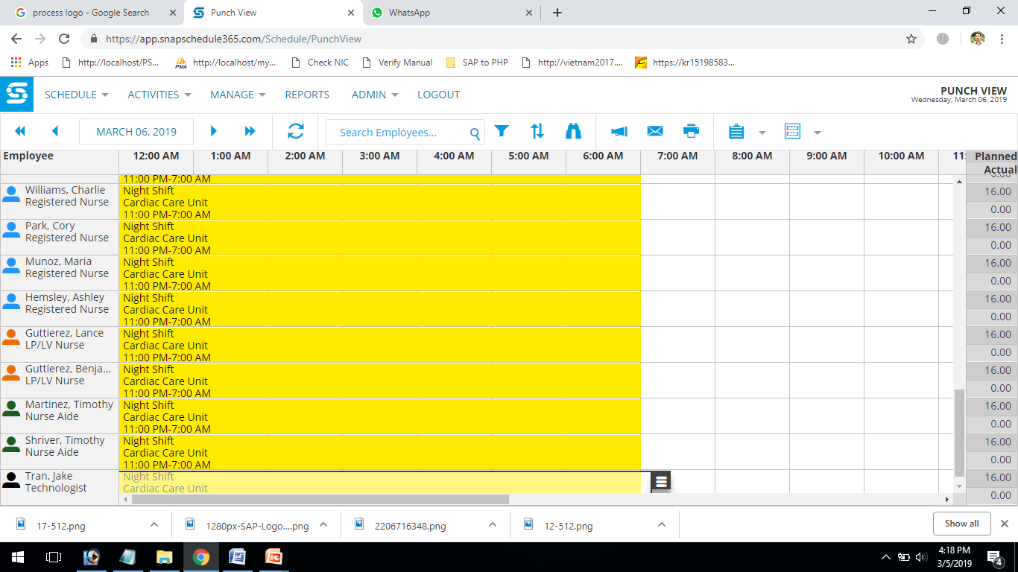
Consideration for SAP Technical Team
SAP team needs to convert the data as per the format below:
Example: Employee 100203 has clocked in at 7.30AM on 31st Dec 2019 requires in a format as p10201901317300000100203”

Below tables are meant only for SAP technical Team for their clarification for the format
Field | Format | Remarks
Time Event Type | P10 or P20 | Provide P10 for Clock in&P20 for Clock Out
Login Date (YYYYMMDD) | 20190131
Login Time (HHMMSS) | 73000
Personnel Number | 00100203 | 00100203

SAP has to convert in the below format before uploading.
Field | Format | Remarks
Time Event Type | Clock in-P10,Clock out -P20 | Provide P10 for Clock in&P20 for Clock Out
Terminal ID | 100203 | Perner id
Login Date (YYYYMMDD) | 20190131
Login Time (HHMMSS) | 73000
Date of Entry in SAP (YYYYMMDD) | 8Spaces | Convert as System Date
Time of Entry in SAP (HHMMSS) | 6Spaces | Convert as system Time
Time Recording ID | 8Spaces | 8 Digit Perner
Personnel Number | 00100203 | 00100203

Roster Inbound
Position | Field Name | Data Type | Length | Short Description | Remarks
1 | Roster_Code | CHAR | 8 | Roster Description
2 | PERNR | NUMC | 8 | Personal Number
3 | From Date | DATS | 8 | Roster Start Date
4 | To Date | DATS | 8 | Roster End Date

Sap has to convert the above Roster data in the below format and upload in the PA2003 table.
The Roster value will be passed in the parameter table along with the code NFRROS and take the process name and create a Roster record in the table PA2003 with the start and end date given by TIMENEX.

Integration steps and Role of each Party

Using SOAP Protocol, all HR Personal information will be sent to SAP Process Orchestration (PI/PO) system which is a middleware to transfer data from SAP S/4 HANA system to Time Recording System.
1

Role of Kaar: Background program to be scheduled in SAP system which initiates the HR Personal data transfer to Time Recording system on a daily basis. SAP will post the data to the webservice Personal data update action of webservice shared by Time Recording system.
The first run will contain data for all employees. Subsequent runs will be only incremental data – changed or additional data for employees
Role of Time Recording System: Time Recording System needs to share their web service URL in which SAP will post the HR Personal data. Once data processed successfully, Time Recording system responds with Success / Failure message.






SOAP Response
Master Data
Generate XML
Trigger: fetch Employee data
Employee Data
SOAP Request
Read SOAP XML
Extract Data

Store Data

OUT BOUND
Frequency of Data flow: Once in a day 11: 55 pm.

Roster data will be sent to SAP Process Orchestration (PI/PO) system which is a middleware to transfer data from SAP S/4 HANA system to Time Recording System.
2

2

Role of Kaar: Background program to be scheduled in SAP system which initiates the Roster data transfer to Time Recording system. SAP will post the data to the web service Roster data update action of web service shared by Time Recording system.

Role of Time Recording System: Time Recording System needs to share their web service URL in which SAP will post the Roster data. Once data processed successfully, Time Recording system responds with Success / Failure message.





SOAP Response
Master Data
Generate XML
Trigger: fetch Roster data
Roster Data
SOAP Request
Read SOAP XML
Extract Data

Store Data

OUT BOUND

Frequency of Data flow: Once in a day 11: 55 pm.

3

3

Absence data will be sent to SAP Process Orchestration (PI/PO) system which is a middleware to transfer data from SAP S/4 HANA system to Time Recording System.

Role of Kaar: Background program to be scheduled in SAP system which initiates the Absence data transfer to Time Recording system. SAP will post the data to the webservice Absence data update action of webservice shared by Time Recording system.

Role of Time Recording System: Time Recording System needs to share their webservice URL in which SAP will post the Absence data. Once data processed successfully, Time Recording system responds with Success / Failure message.






SOAP Response
Master Data
Generate XML
Trigger: fetch Absence data
Absence Data
SOAP Request
Read SOAP XML
Extract Data

Store Data

OUT BOUND

Frequency of Data flow: Event based, once the leave record gets approved in SAP.
4

Public Holidays information will be sent to SAP Process Orchestration (PI/PO) system which is a middleware to transfer data from SAP S/4 HANA system to Time Recording System.

Role of Kaar: Background program to be scheduled in SAP system which initiates the Public Holidays data transfer to Time Recording system. SAP will post the data to the webservice Public Holidays data update action of webservice shared by Time Recording system.

Role of Time Recording System: Time Recording System needs to share their webservice URL in which SAP will post Public Holidays data. Once data processed successfully, Time Recording system responds with Success / Failure message.





SOAP Response
Master Data
Generate XML
Trigger: fetch Holiday data
Holiday Data
SOAP Request
Read SOAP XML
Extract Data

Store Data

OUT BOUND

Frequency of Data flow: Once in a day 11: 55 pm.

5

Time Recording System will send the Clock in/Clock out data at regular intervals to the SAP system through SAP Process Orchestration system (SAP PI/PO).

Role of Kaar: SAP needs to share the webservice URL to Time Recording System to post the Clock in/Clock out data to the webservice and consume the data that is sent by Time Recording System.

Role of Time Recording System: Time Recording System use the webservice shared by SAP to post the Clock in/Clock out data to the Time Events update action of webservice.





SOAP Request
Read XML
Store Data
Trigger: fetch Check in/out data
Check in/out Data
SOAP Response
Generate XML
Extract Data

Data Base

IN BOUND

Frequency of Data flow: Every 10 minutes, the data needs to be pushed.

6

Time Recording System will send the Roster data at regular intervals to the SAP system through SAP Process Orchestration system (SAP PI/PO).

Role of Kaar:SAP needs to share the webservice URL to Time Recording System to post the Roster data to the webservice and consume the data that is sent by Time Recording System.

Role of Time Recording System: Time Recording System use the webservice shared by SAP to post the Roster data to the Time Events update action of webservice.





SOAP Request
Read XML
Store Data
Trigger: fetch Roster
Roster Data
SOAP Response
Generate XML
Extract Data

Data Base

IN BOUND

Frequency of Data flow: Once in a day 11: 55 pm.

Handling Errors

In case of failure in integrating data, HR Personal information, Roster, Public Holidays and Absence data backup is carried in SAP log table and Time Integration System will send the failure response to PO and the same will be updated in SAP log table. In case of any network failure or in lack of response from Time Recording Terminal, failure status will be updated in SAP log table. Manual intervention is required to correct the data in SAP to send the updated data through SAP PO or manual update is needed in Time Recording System based on the error message.

Note: If the frequency of the interface is every 1 day, provision of manual triggering of interface is required, once the issue is fixed.

Following are some common reasons for failure and actions required, this list is not covering all possible issues, other than below issues individual items needs to be addressed based on the individual actions required to address the issue.
Reason of Error / Failure of Interface | Identification of issue | Action required
Application / DB down (including SAP, PO/PI and Time Attendance system)
Data issue
Network issue / down
System down due to maintenance activity

Points to be noted
Any duplicate record shall be avoided to be send to SAP by TIMENEX system, duplicate means any attendance record created within 10 minutes shall not be send to SAP, e.g. 1st punch in record created at 7:30, another punch in record was created at 7:38, the second record shall not be send to SAP. Any wrong entry also requires to be validated at the TIMENEX system.
If a Time recording terminal provides two time Pairs, it should be accepted by SAP
For example employee works from 07:30 to 15:30
1st time pair: 07:30 to 15:30
And if he is called again in the evening 18:00 to 20:00
2nd time Pair: 18:00 to 20:00
If Punch in or punch out missing SAP should have a provision to regularize missing punch.
Employee wise roster will be generated in TIMENEX system, which will flow to SAP, SAP will provide only the roster definition (start and end time of each shift), which needs to be mapped to each employee at TIMENX system.

Shifts Definition, Creation

Shift work is an employment practice designed to make use of, or provide service across, all 24 hours of the clock each day of the week (often abbreviated as 24/7). The practice typically sees the day divided into shifts, set periods of time during which different groups of workers perform their duties.
The shifts timings and numbers can vary per organization requirements. At Naufar there are a number of units working in day/night shifts. The shifts managers or unit supervisors are responsible for managing staff duties at their units. Units can be divided by services they provide, some units like Residential there are 3 shifts in a single day, employees are divided to work in three shifts day and night.

Working Days
Usually at Naufar there are five days [Sun-Thu] in which the employees have to work in shifts or units. During the working days a staff member can only perform duty in one shift and is not allowed to work in consecutive shifts. To work in the next shift he/she shall have a gap of one shift means after 8 hours rest he/she shall be allowed to work in next working shift/day. There are units which have only one shift per day. The staff managers working at these units are managing staff for single shift only.
Units like Residential there are 3 shifts of 8 hours in each 24 hours/day. There is no off on the state defined off days like Friday or Saturday. But after working in five consecutive shifts/days the employee can avail two days off.

Off Days
Normally at Naufar there are two days off and five days work. From Sunday to Thursday the employees do five days work. Units like Residential employees can only avail off after five shifts/days work.

Overtime
When there is a need of staff at units the shifts supervisor calls the other staff members for duty. The extra time they consume at unit shall be counted as overtime. The overtime calculation shall be managed by shift supervisor. The allowed overtime is 3 hours.

First on-call
When unit supervisor need staff to cover the requirements at unit and there is staff deficiency then they call for other staff members for duty. The employee if on first-on-call shall be called for duty first.

Second on-call
He the first on-call performed his/her duty recently then the second-on-call is called for duty or whatever the shift supervisor decides.

Swap duty
The unit supervisor after allocating duties to staff member can change ones duty with other if the first one have some emergency or want swap duty.

Types of shifts at Naufar
Three types of rosters available at Naufar:
- 24/7, Three Shifts / Day (A, B, C) with on-call schedule
  - A, B, C, D during Ramadan (Four Shifts / Day) with on-call schedule
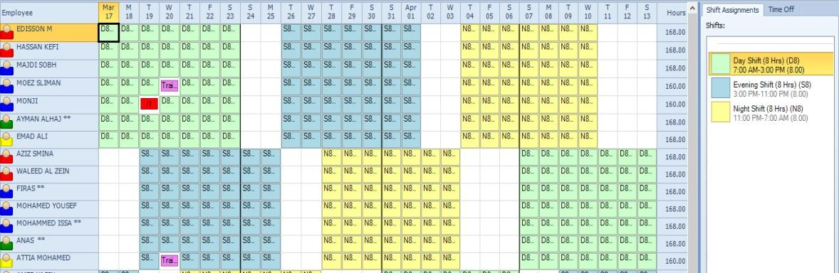
- Two Shifts/ Day (Morning and Evening)
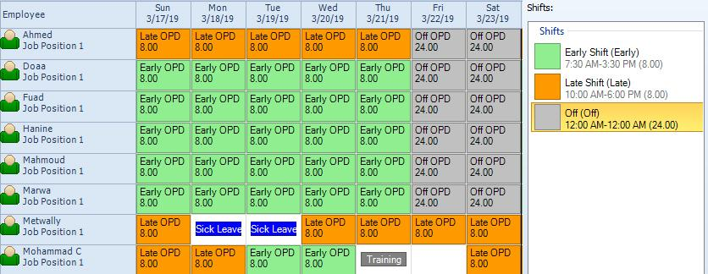
- One Shift / Day
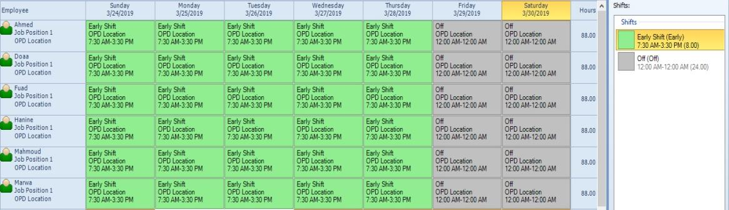

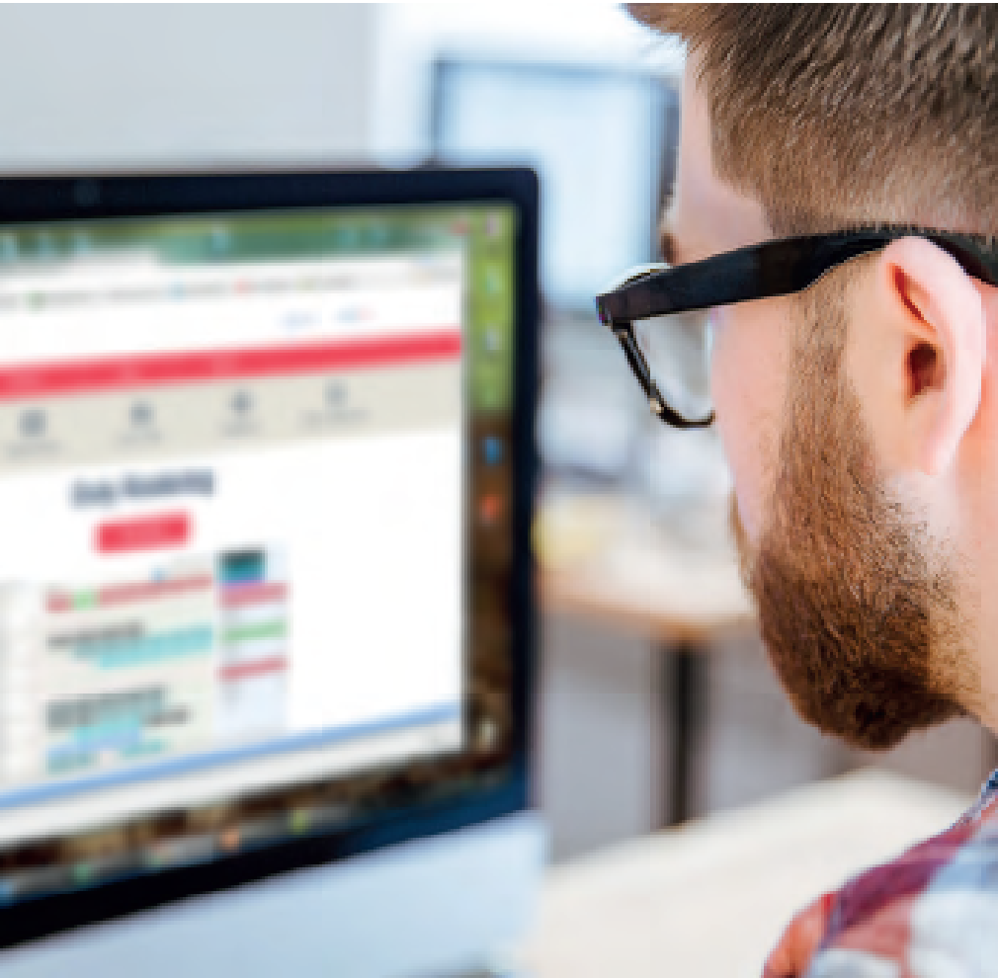

- Morning Shift: Start time (07:30), End time (15:30)
- Late Shift OPD: Start (10:00), End time (18:00)
- Evening Shift: Start time (14:30), End time (22:30)
- Night Shift: Start time (22:30), End time (07:30)
- Weekend Shift OPD: Start time (09:00), End time (17:00)

Clinical Units


Naufar is divided into 8 clinical units. Each unit provides its own specified services.
  - OPD
  - Buprenorphine Clinic
  - Residential
  - Directed Care Service
  - Villa Service
  - Recovery and Engagement
  - Halfway House
  - Young Persons Wellness
  - Ladies Wellness Service

Shift creation Guide lines

- Each unit head will prepare the staff roster 5-10 days before the month’s start.
- The staff roster should be linked with the Time Attendance System
- The staff roster should display the approved leaves and the public holidays maintained in SAP
- The staff roster should be generated based on the staff approved leave planned the unit’s requirements
- Each unit head will prepare the roster for his/her unit.
- Each unit has specific requirements (Number of staff for each shift, minimum qualifications required)
- The system should give an alert when the minimum requirement is not met.
- Employees work maximum 6 consecutive days.
- Employee who are requested to work more than 6 days / week should be compensated by overtime as a first option (More than 6 consecutive days can be maintained manually only)
- If overtime is not possible, the HOD will approve compensating the extra working day with time-lieu which will be added to owed time (PO)
- Employees should get a minimum of8 hours’ rest between shifts while doing 8 hour shifts and at least a minimum12 hours if doing 10-12 hour shifts.
- Each roster will have the 1st On-call, and 2nd On-call schedule (RU Only) (other units need on call process as they do not have enough staff)
- 1st On-call staff should be on his/her second day off, 2nd On-call can be on the staff first day off
- The staff roster should have a fair distribution of weekends(Friday and Saturday) between staff where possible
- The employee can request to swap his / her daily shift, after the approval of the second employee and the unit head (email)
- If additional staff available, the priority is for the afternoon shift (B Shift)
- In case of staff shortage, reduce the staff number in the Morning (A Shift), or the Afternoon (B Shift)
- The system should be flexible enough to manage increase in the number of staff per clinical units based on the same rules and requirements.
- Staff should work for a 160 hours in 28-day period.
- If staff works more than 160 hours in 28-day period, then it should be reflected as overtime or a day off at a later date.

Clinical Units Rules and Requirements

Common Staff Requirements (All units) | - 1 x Head Nurse: Morning Shift (5 Days / Week)  - 1 x Nursing Supervisor: Day and Evening shift Sunday-Thursday  - Friday-Saturday 10:00-18:00 1 Supervisor (1 Shift)
OPD Doctors Appointment | - 14x Nurses  - 2 x Assessment Nurse  - 1x New Prescription Nurse  - 1x Charge Nurse  - 1x Triage Nurse  - 1x Booking Nurse  - 7:30-15:30 Sunday-Thursday
OPD Buprenorphine Clinic | - 2 x nurses 2x Nurse specialist  - 1x Buprenorphine Storage Nurse  - 1x Nurse Specialist and 1x nurse 0730-15:30 1x Nurse Specialist and 1x Nurse 10:00-18:00 Sunday-Thursday & 09:00-17:00 Friday-Saturday
Residential | - 24/7 service: Shift M Shift E, Shift N  - 1x in-charge nurse for each sift, morning M, Evening E, Night N,  - 1x quality representative M- shift  - 1x infection control representative M- shift  - 19 x Staff Nurses  - 2 x Nurse Technician  - Need to show in duty roster the staff is working in public holiday and Eids days.  - Minimum staff numbers in the Morning 5 staff + quality and infection control representative  - Minimum staff number in Evening shift 5staff  - Minimum staff number at night 5  - Moving from night shift to morning or evening is not allowed  - Moving from from evening to morning (in the next day) or (in the next day ) night it is acceptable  - Moving from morning shift to evening or and night (in the next day ) is allowed.
Residential Villa 5villas (each villa has one patient ) | - 24/7 service: Shift M Shift E. Shift N.  - 1staff nurse on Morning shift.  - 1staff nurse on Evening shift.  - 1 staff nurse on night Shift  - As per VIP MDT team some time request 1:1 nurse: patient ratio.
Recovery & Engagement | - 5 Days / week (Sun – Thu): Morning Shift  - 6 x Staff Nurses
Halfway House | - 24/7 service: Shift A, Shift B, Shift C  - 1x nurse per shift (From Recovery and Engagement)
Young Persons Wellness | - 5 Days / week (Sun – Thu): Morning Shift  - 4x Staff Nurses
Ladies Wellness Service | - 5 Days / week (Sun – Thu): Morning Shift  - 5x Staff Nurses

Roles and Responsibilities

Human Resources (HR)
- Executing and implementing the policy into Naufar practice.
- Highlight breaches to policy and take appropriate action as defined in relevant policy
Supervisors
- Ensuring the reportees are adhering to the Naufar Time & Attendance Policy
- Highlight breaches to policy to HR for taking appropriate action against the employee
Leads/ Managers
- Drive the implementation of approved policies relevant to function.
- Ensure effective communication of relevant policies to all staff within their function
- Ensure that staff has the knowledge in adhering to the policy.
Staff
- Adhering to this policy.
- Identify and inform if there is any variance in daily clock in/clock out and highlight to HR.
- Participate in the development and implementation of policies as part of their normal duties and responsibilities.

Shifts Roster Creation

Shifts creation requires pre-calculation of some important factors to be used in shifts. For each unit the system shall allow unit supervisor to create shifts separately for Morning, Evening and Night.
The units are divided into three categories having multiple numbers of shifts. The units like Recover and Engagement have shifts from Sunday to Thursday only in the morning. So here the unit supervisor shall create only one shift per day in the morning time category. Unit like OPD there two working shifts one in the early hours and second starts in late hours. The unit supervisor shall be allowed to create two shifts as per unit requirements.

The main Residential unit as per its requirement there are three shifts in each 24 hours having total of 8 hours duration. Each shifts starts exactly after the last/third one ends. In three shifts units there is no off on Friday or Saturday except an employee completes five consecutive shifts then he/she can avail two days off.

Below are the main processes through which the system shall pave path to create shifts in each unit. The created shifts shall be recorded and can be editable at any time allowing unit supervisor to save modification whenever required.

Step 1

Determine the number of staff required in a Unit
This is the most important stage at the startup where a unit supervisor decides on the number of employees to keep in certain shift. The unit supervisor shall first overview his/her unit requirement, suppose the supervisor have a number of 50 employees available having various type of job description. The unit supervisors then decided on each employee duty assignment. The system shall allow unit supervisor to add new types of job designations like shift supervisor, charge nurse. While creating shift the system shall require the number of staff by designation just like shown in below form.

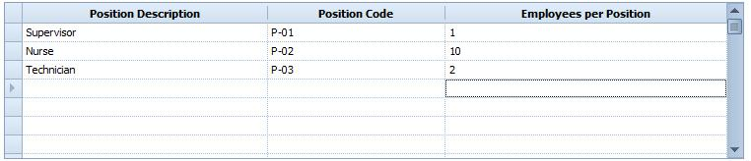
The above form requires mentioning the number of staff by designation, suppose here we added 1 supervisor against a shift. If there are three shifts in a unit then the number of supervisors shall be 12. Similarly others staff number can be added via the above form.

Step 2

Determine the Pattern of the Rotation
Duties are assigned to employees based on a specific pattern. The employees work for five days a week and two days off. The duties assigned to employees shall be distribute in such a manner that every employee shall have same number of working and off days. Assigning five days work and two days off creates a pattern like structure as shown in below picture.
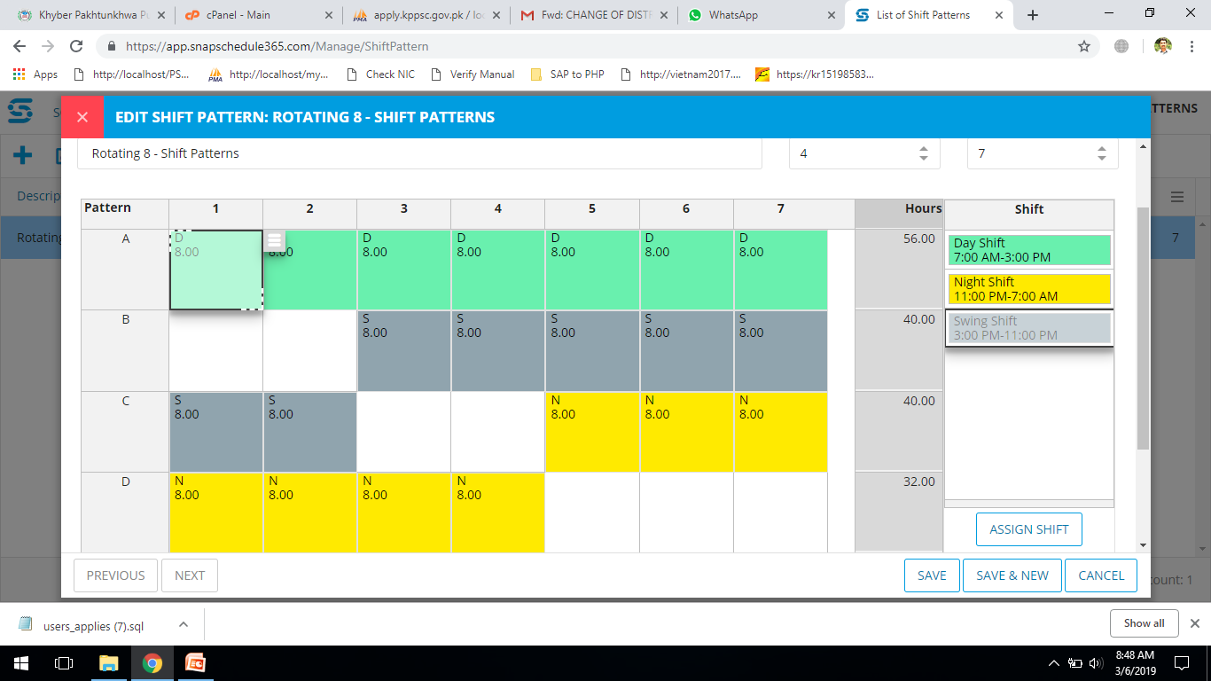

Step 3

Selection of Staff
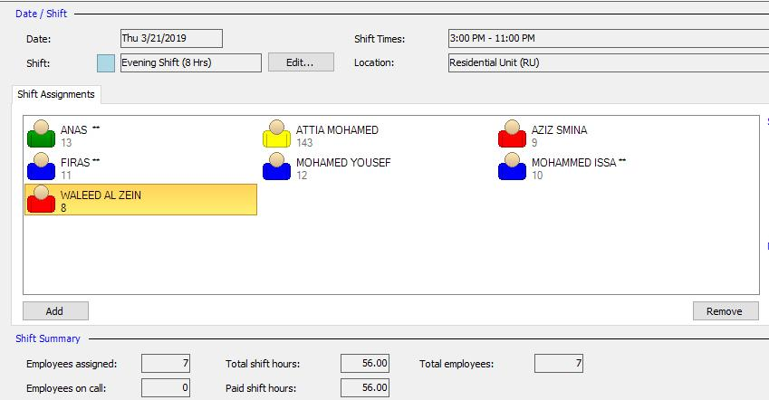
After finalizing the number of required staff in a unit the supervisor shall select or pick names of employee to work in a shift.

The employee selection shall be based on designation already mention in required staff form. This creates a team of employee who shall work in a specific shift or unit. After creation of shift or after implementing the shift the supervisor shall have privileges to change any employee duty. He/she can add or remove employee from the duty roster.
Step 4

Create Shift
After employee selection, the unit supervisor now creates the actual shift as shown in below picture. The system shall provide detailed view of the shifts already created.
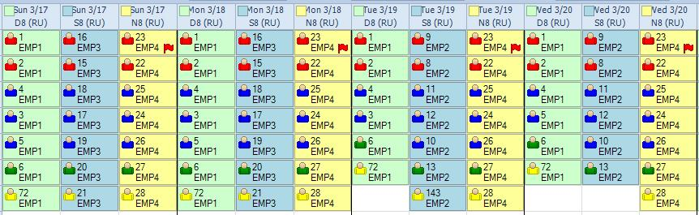

Reports

View Reports
Shifts are created and implemented at various locations; devices are fixed to collect the attendance data of employees. The unit supervisor to watch employee performance or attendance the system shall provide a variety of reports through which the supervisors and other administrative staff can plan future decision.
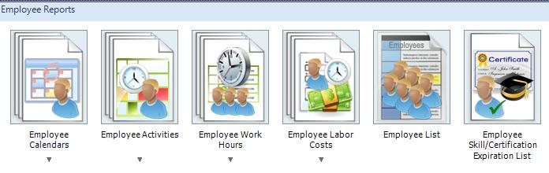
System Feature List

Web based software capable of Communicating with several clients in real time featuring:
- Add/remove/restrict/configure terminals.
- Employee enrolment.
- Adding holidays and holiday types.
- Overtime and Vacations time.
- Attendance Rules.
- User Management.
- Capability of generating different detailed and summary reports like in-time/out-time wise, Employees wise, Department/Section/Shift wise, Day/Week/Month/Year wise, Temporary in/out wise, Location wise report etc.
- Security features like read-only database to administrators and remote logging on any attempted change to the database.

Dashboards
The new proposed system shall provide facility for each and every user having a dashboard at home page after login to system. The dashboards provide a compressive analytical display mechanism for all managers. The dashboards shall include the overall time in & out, leave records, attendance record, and late comer etc. A graphical presentation of data shall create an interactive environment wherein manager shall view and track day to day employees performance as far as attendance is concerned. The dashboard will have glued buttons for having switching on or off settings. The managers will prefer to use the dashboards instead of going to reporting tool for viewing and reporting each and every employee. The dashboard will highlight those who came late today.

Multiple Day Shifts
The new proposed system shall have settings for shift managements. A separate module shall be incorporated for shift management. The managers can add, edit and readjust shifts timings and hours settings.
For each shift the manger require to add it total number of hours, its start time, end time etc. The system shall suggest timings setting to mangers for creating and managing shifts straightforwardly. The system shall also notify the manager’s in-case of any conflict with other shifts.
Once a shift is created the managers can now add new employees to it. The system also provides facility for managing employees within shifts. They can interchange their shifts and duty timings.
Usually 24 hours are divided among three shifts, in Nuafar case there are other shifts also like Ramadan, wherein shifts timings are settled according to local time settings of Ramadan.

Track Absences & Accruals
Biometric devices shall be installed at the Naufar premises, which shall collect the time attendance data and shall forward the same in real time to the main server. The managers can now review the reports generated by system and note the late comers or absent employee.
The system shall lock the employee records of time in and time out, each and every minute is important, the system shall calculate the same and present them in a summarized format to mangers.

Control when & where Employees clock in
Hundreds of employees and their shifts can be managed via the system. The top level mangers shall have dashboards for each and every shift to view the exact present number of employees. These reports shall be further integrated with the employee payroll; the main SAP system shall calculate the monthly salaries based on attendance data collected by T&A system.
The managers shall have full control over the employee’s timings, and can track where and when he or she clock in. implementation of such an accurate system shall pilot a punctual environment.

Overtime Management
The overtime calculation for payroll can be a pain, with different rates and terms and conditions for different individuals and types of work done. At the Naufar the newly proposed system shall do the same job easier and effortlessly.
The system shall calculate the employee’s overtime, and shall generate reports of the same which employee had work. The system shall separate overtime settings to better track the work performed by employees. In-case of paying overtime wages to both hourly and salaried employees, that’s why separate settings are important. The settings will allow setup the work week start and ending day for overtime purposes. Then managers will be able to calculate overtime for a 40-hour workweek, an 80-hour workweek and overtime paid out on individual work days.

Lunch & break settings
The 24 hours are segregated among various shifts at the Naufar, employee’s clock in at specified time and clock out at end time. The top managers set or decide timings on breaks and Nimaz timings.
The newly proposed system is designed to regulate break timings as per policy decisions. The managers shall feed break timing in system and the system shall automatically calculate or deducted the break timings from the overall duty hours. As the system is designed for shift purposes, it will allow managers to have break timings in each shift.

Role based user access levels
In today’s era software are not built for a single user, there can be a number of users who shall interact with it. Now each organization like Naufar has number of mangers level, each and every manager have his or her own tasks and responsibility to do.
The newly proposed system shall accompany all the capabilities to accommodate large number of users based on their roles. The role is a designation or level where it has some job descriptions. A person hired on a specific job or designation shall perform the same responsibility which the designated job has. The system shall work on the same procedure, it will have role management module, built for creation, editing etc of roles.
At the startup the top manager shall first enter all the roles into system, and will assign privileges as per policy. The privileges include accessing of system’s various parts like adding forms, editing forms; reporting etc. after assigning privileges to roles, a user can only access those forms whosever accessed is authenticated to his or her role. Suppose a computer operator can only view and print some specific reports as his or her role is only allowed to access certain reports. The managers at top level can view even more pages and modules as per setting for their role.

Multi language
Good system are rated higher as compared to other the reason behind is the facilities it provides to its users, the more facility a software provides the more it will be liked and accepted. Also it shall work and in every environment or multitude of people. The world is multilingual; software built for specific area shall not work anywhere else when it comes to language selection.
The newly proposed system is a web based system; have setting for language settings, its designed to support multiple languages like Arabic also. The language settings are saved to users preferences and the system set language after every login which is preferred. The language settings shall be available to each user and the top of application wherein the user can select the language from menu and saves the same.

Centralized view for managers
Biometric devices shall be installed at premises of Naufar; these devices shall collect data and will send the same to main server. The managers at the Naufar can view and report the data collected from various devices. The system shall provide facility for managers to have centralized view of all the attendances collected. The data shall be use for various decision making and payroll calculations. The managers shall have dashboards built to provide switch panel on system.

Advanced exporting tool
Data collected from various devices, the system shall provide facility to users and manager to generated reports, and export them to format like MS Word, MS Excel, PDF, JPEG etc. The system shall fix icons on top of every report allowing users to click, on a single click the system shall automatically shift data to desired format and will stores to same to user’s computer.

Manual hours allocation
For creation of new shifts the system will provide forms available on shift module. The top mangers when creating a new shift can set the working hours for, the mangers can give the hour’s manual and set the shift to run.

Real time data collection
At the time of clock in or clock out the biometric devices shall transfer the data to main server in the real time. It will allow managers to check and balance the present employees in a specific department. The biometric devices shall be connected to main server via cellular networks or local area network. These devices stores locally within its memory and when it makes connection with the main server the data is sent forth. The managers can also extract the data as and when they require from devices.

Employee self-service
The newly proposed system shall allow users or employees to check log in, logout timings, total hours, total attendance etc. They shall be able to know about the total overtime calculations, paid time balance etc. They can view the schedule of duties and also the shift rotation if any. An employee also requests for change in shift or change in duty hours. The system shall allow managers to change the shift as per request made.

Absence Management
The newly proposed system for Naufar shall have facility for managing the presence and absence of employees. The system shall monitor absence as well as presence, including absence due to sickness, holiday or vacation days, or paid time off. Managers and teams have access to an up to date picture of who should be in work, who is and who isn’t, and can plan accordingly.
Addition to monitoring presence, Time and Attendance system can help you to manage absence. Whether it’s unexpected due to sickness, holidays or vacation days, or paid time off – it should be easy for managers to see at a glance who’s in, who isn’t, and what each person’s entitled overtime and allowances are.

Flexible Employee Scheduling
The new proposed shift management system at Naufar shall empower the managers to set the employee hours in any available hour, where he or she chooses for placement. System shall be flexible enough to schedule that allow employees to start and end their days at different times. Others prefer to keep the workday more formal and wish to prevent employees from coming in early or working overtime. Time and Attendance system shall go beyond than just monitoring the presence (or otherwise) of employees. The software shall allow managers to create and manage schedules and rosters, and such functionality usually comes equipped with alerts and notifications relating to overtime, poor attendance, etc.

Elimination of Missed Punches
Old fashioned punch clocks were the subject human error. It was easy for an employee to return from lunch and begin work forgetting to stop by the time clock to punch in. By the time error was realized it may have been the end of the shift. A manager would be required to verify the correct time. The new proposed system is designed to alert the manager and the employee to a missed punch through self-service portals and mobile alerts, stopping the problem before it becomes an issue

Time Management
One of the main functions of the proposed T&A system, it’s time management features track employee presence. Time trackers monitor how much time is spent at work, working overtime and the time spent during work hours. Time management functions as a productivity measure as well as a tool assisting in financial decisions. When a business is able to track time automatically through software, compensation can be easily calculated.

Attendance Management
Attendance management feature of the new proposed system shall handle standard tools used for attendance tracking, such as clocking in and out. This automates the process of employee time tracking. Meanwhile, attendance is automatically tracked and recorded.
The Biometric devices shall work as data collection point where the collected data shall further send to main server on cloud. Biometrics requires identification in the form of a fingerprint, eye pattern or voice in order to clock in and out and access other features. Biometrics also helps avoid people clocking in for late or absent coworkers.

Absence and Leave Management
The feature of absence and leave record, give employees the tools to manage their own time off requests, including the tracking of planned absences due to appointments, vacations and holidays. Employees can view leave information, like calendars, and request time off through the new system. The system shall track leave and monitors benefits.

Employee Management
The system shall provide features to add new employee. Ease of use is facilitated through employee management features. All the employees’ information shall be integrated with main SAP server to maintain the integrity of data and remove the anomalies. The goal of these features is to make time and attendance information easily visible to all members of an organization.

The Naufar staff information including the biometric information shall be collected via devices and stored to main server. As new software shall reduce errors in attendance management it leads to accurate payroll processing and reduces payroll redundancies.

Data Integrations
Time and attendance systems can also be integrated with the already running SAP system. All HR data is available in a single system, providing a comprehensive, all-in-one place for employee management functions. The easiest integration facility shall be available to Naufar system managers.

Business Intelligence and Reporting
The inclusion of embedded business intelligence in time and attendance solutions provides a platform for the evaluation of overall performance in relation to time. The reporting tools incorporated within system shall compile data on employee attendance, analyze the findings and create reports. These reports shall present data insights in a visually informative medium. The analysis offered by business intelligence features aids in future decision making and changes made to attendance policies. Some main report areas:
- Performance Management
- Financial Reporting
- Activity Reporting
- Attendance Reporting
- Time Off Summary
- Leave Reports
Powerful dashboards and reporting tools shall be provided to managers at Naufar for viewing reports and administer accordingly. The system is designed to have multiple level of dashboards for each and every user, presents the summarized version of attendance. The present employees day or pay calculations are now easier with the help of attendance reports, generated via powerful reporting mechanism.
Integration with the payroll system further allows managers to have hands on the system. Integrated with the employee payroll; the main SAP system shall calculate the monthly salaries based on attendance data collected.

System Architecture

Model-View-Controller (MVC) Architecture
MVC is a software approach that separates application logic from presentation. In practice, it permits your web pages to contain minimal scripting since the presentation is separate from the PHP scripting.
- The Model represents your data structures. Typically your model classes will contain functions that help you retrieve, insert, and update information in your database.
- The View is the information that is being presented to a user.
- The Controller serves as an intermediary between the Model, the View, and any other resources needed to system the HTTP request and generates a web page.

Technology Road Map
In current business time every organization has to best quality web portal in design and development sector for online business. During this competition the best development frame work need to be selected among development technologies.
For this project PHP as front end and SQL Server as backend database is the preferred framework due to the following reasons
- PHP is an easy-to-use development framework that allows developers to cut down on code lines and speed up the development process.
- With PHP framework PHP specialists write their code in MVC environment; get a chance to follow a clearly defined three-tier architecture and not to mix presentation and logic.
- PHP is ORM-based and enables PHP developers to stick to OOR programming paradigm and easily mange tables and classes.
- PHP web framework has an articulate directory structure, which allows PHP developers quickly locate everything they did in a proper directory and avoid tweaking configuration files. Eventually, it gives PHP development specialists an advantage of faster deployment time.
- PHP supports Ajax, JavaScript, XML and other languages and technologies.
- PHP ensures robust security and authorization for future web applications.

Hardware and Technology Requirement

A windows based server shall be required with remote access to manage the application and other software for implementation.

Operating System Requirements
A windows based system shall have at least windows server 2012, or its higher version. The windows can be 32 or 64 bit.

Servers Requirements
  - Application Server and Database server
A server with octa-core processor with at least 2.5 GHz clock rate recommended for convenient performance. Slower processors may be also used, but the fingerprint or face processing will take longer time. For fast processing speeds the higher hardware speed the higher processing speed.
  - Backup Server
Parallel to application and database server a backup server is also needed to schedule backups, in-case of any failure the backup system can be used to restore data.

Tools required
  - PHP
A server side scripting language for creating dynamic pages. The PHP processor shall be require on server to process php files.
  - Apache
A web server like Apache shall be installed to handle clients request and create response.
  - MS SQL Server
The database management system shall provide a data storage for time attendance.

